Applied Maths Higher Level Deferred paper 2022

2022 Deferred paper 1 (a)
Two cars, A and B, travel along a straight level road in opposite directions.
A passes point P with speed 4 m s⁻¹ and uniform acceleration 2 m s⁻².
Three seconds later B passes point Q with speed 5 m s⁻¹ and uniform acceleration 4 m s⁻².
The distance from P to Q is 1143 m.
The cars meet t seconds after A passes P.
Find the value of t.
Find the distance from P to the meeting point.
Find the distance between the cars when A is 160 m from the meeting point, before the cars meet.

2022 Deferred paper 1 (b)
An object falls vertically, from rest, from a height h metres. It travels $\frac{15}{64}h$ metres during its final second of motion before hitting the ground.
Find the time it takes to fall to the ground.
Find the value of h.

2022 Deferred paper 3 (a)
A particle is projected from a point on horizontal ground.
The speed of projection is 14 m s⁻¹ at an angle 𝛼 to the horizontal.
Find the two values of 𝛼 that will give a range of 10 m.

2022 Deferred paper 4 (a)
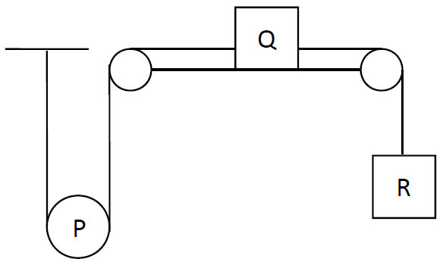
A taut light inelastic string is fixed at one end and passes under a moveable pulley, P, of mass 4 kg which hangs vertically. The other end of the string is attached to Q, a mass of 4 kg which lies on a rough horizontal surface.
A second inelastic string connects Q to R, a mass of 10 kg which hangs vertically.
The fixed pulleys are smooth and light and the coefficient of friction between Q and the surface is ½.
The system is released from rest.
Find the accelerations of P, Q and R in terms of g.

2022 Deferred paper 5 (a)
A smooth sphere, P, of mass 3m collides directly with another smooth sphere, Q, of mass 5m.
P and Q are moving in opposite directions before impact with speeds 4u and 2u respectively.
The coefficient of restitution for the collision is e.
(i) Find the speed of P and the speed of Q after impact in terms of u and e.
(ii) If P and Q are moving in the same direction after impact, show that 0 ≤ e ˂ $\frac{1}{15}$ .

2022 Deferred paper 5 (b)
A smooth sphere, A, of mass m collides obliquely with
another smooth sphere, B, of mass m.
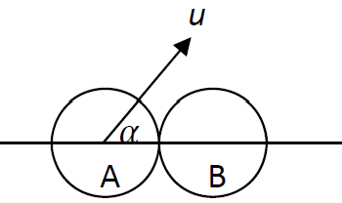
Before impact, A is moving with speed u at an angle 𝛼 to the
line of centres of the spheres, where 0° ≤ 𝛼 ˂ 45°.
B is at rest before the impact.
The coefficient of restitution for the collision is e.
(i) Find the speed of A and the speed of B after impact in terms of u, e and 𝛼.
(ii) Given that A is deflected through angle 𝛼 because of the collision, show that tan² 𝛼 = e.

2022 Deferred paper 6 (b)
A particle of mass m is suspended vertically from a fixed point O by a light inelastic string of length d metres.
The particle is projected horizontally with speed u, where u² = 4gd.
Show the string goes slack when it makes an angle $\cos^{-1}{\frac{2}{3}}$ with the upward vertical through O.

2022 Deferred paper 10 (a)

- Solve the differential equation $(1+t^{2}$)$\frac{dr}{dt}$ = 1 given that $r=0$ when $t=\frac{π}{4}$.

- If $\frac{dy}{dx}=(y+4)\cos^{2}{3x}$ and $y=-3$ when $x=0$, find the value of y when $x=\frac{π}{6}$.

2022 Deferred paper 10 (b)
A particle is projected horizontally along a smooth horizontal surface with initial speed 80 m s⁻¹.
The particle has a retardation of $\frac{v}{100}$ m s−², where 𝑣 is the speed.
Find
(i) the speed of the particle after t seconds
(ii) the distance travelled in t seconds
(iii) the speed 𝑣 in terms of the distance travelled, s.

